

**Week 4:** Deployment on Flask

**Name:** Darshan Dhanani

**Batch code:** LISUM32

**Submission date**: 28 Apr 2024

**Submitted to:**

**Snapshot of Model Deployment**

**Step 1:** find and download data

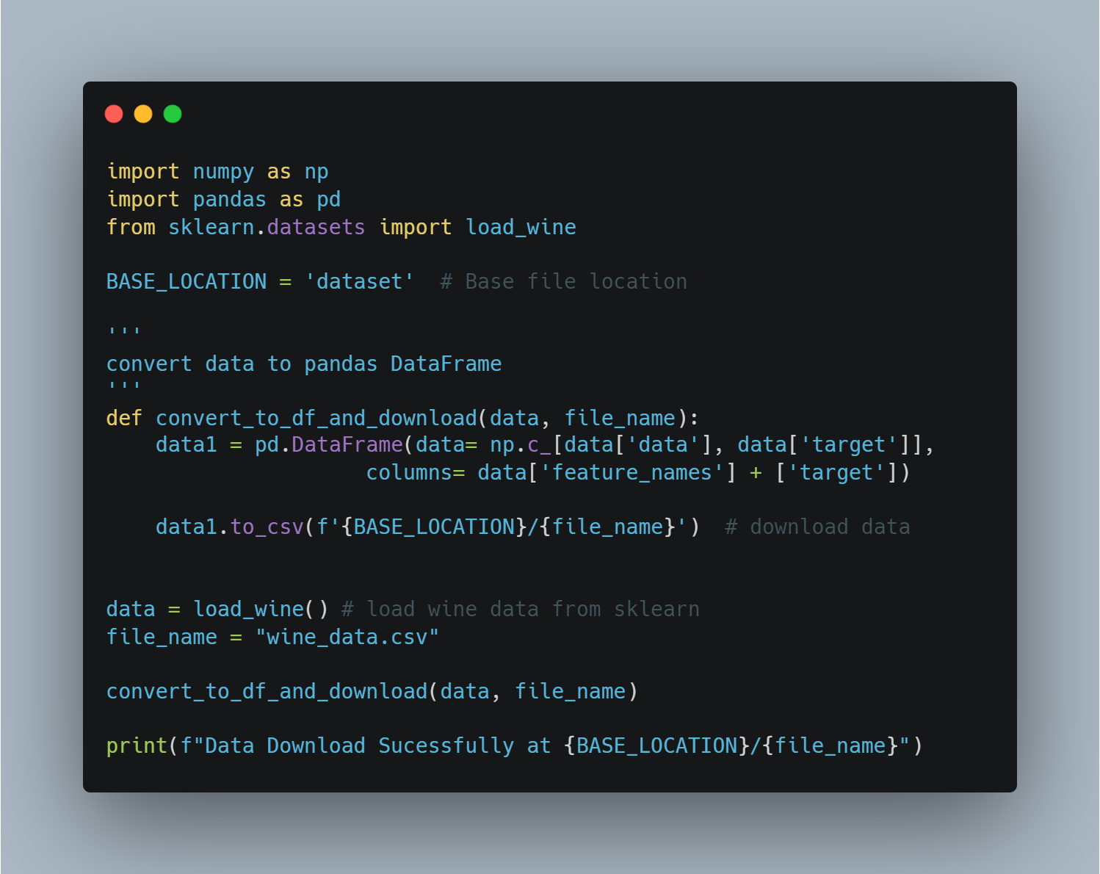

**Step 2:** Data Preprocessing

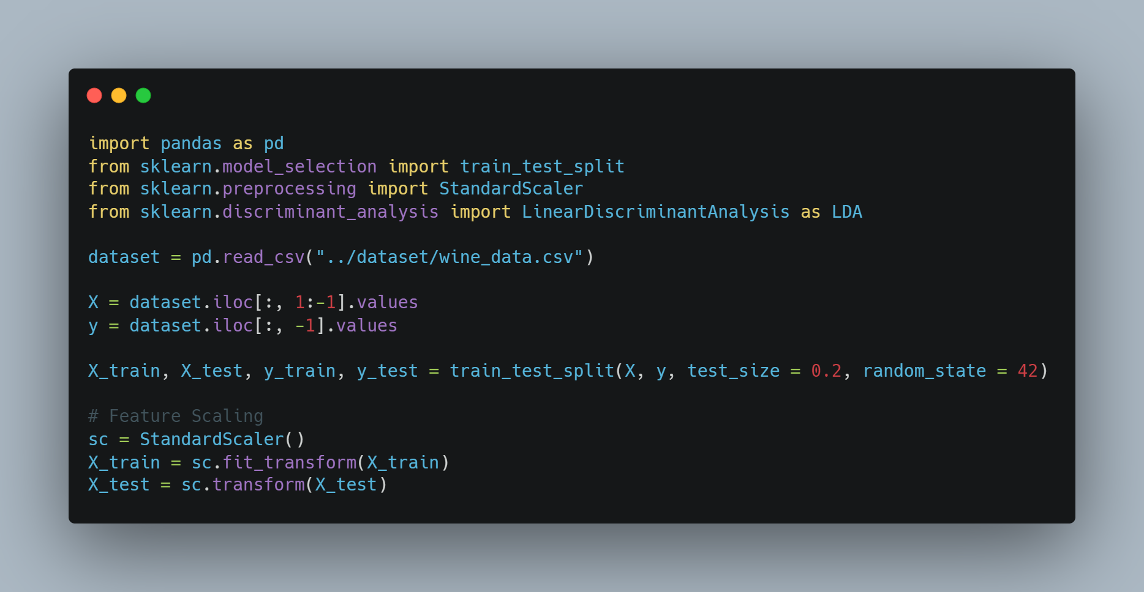

**Step 3:** Building and Training a Model: Creating a .pkl File for Export

After thorough experimentation with various models, I've chosen to present the K-Neighbors Classifier here.

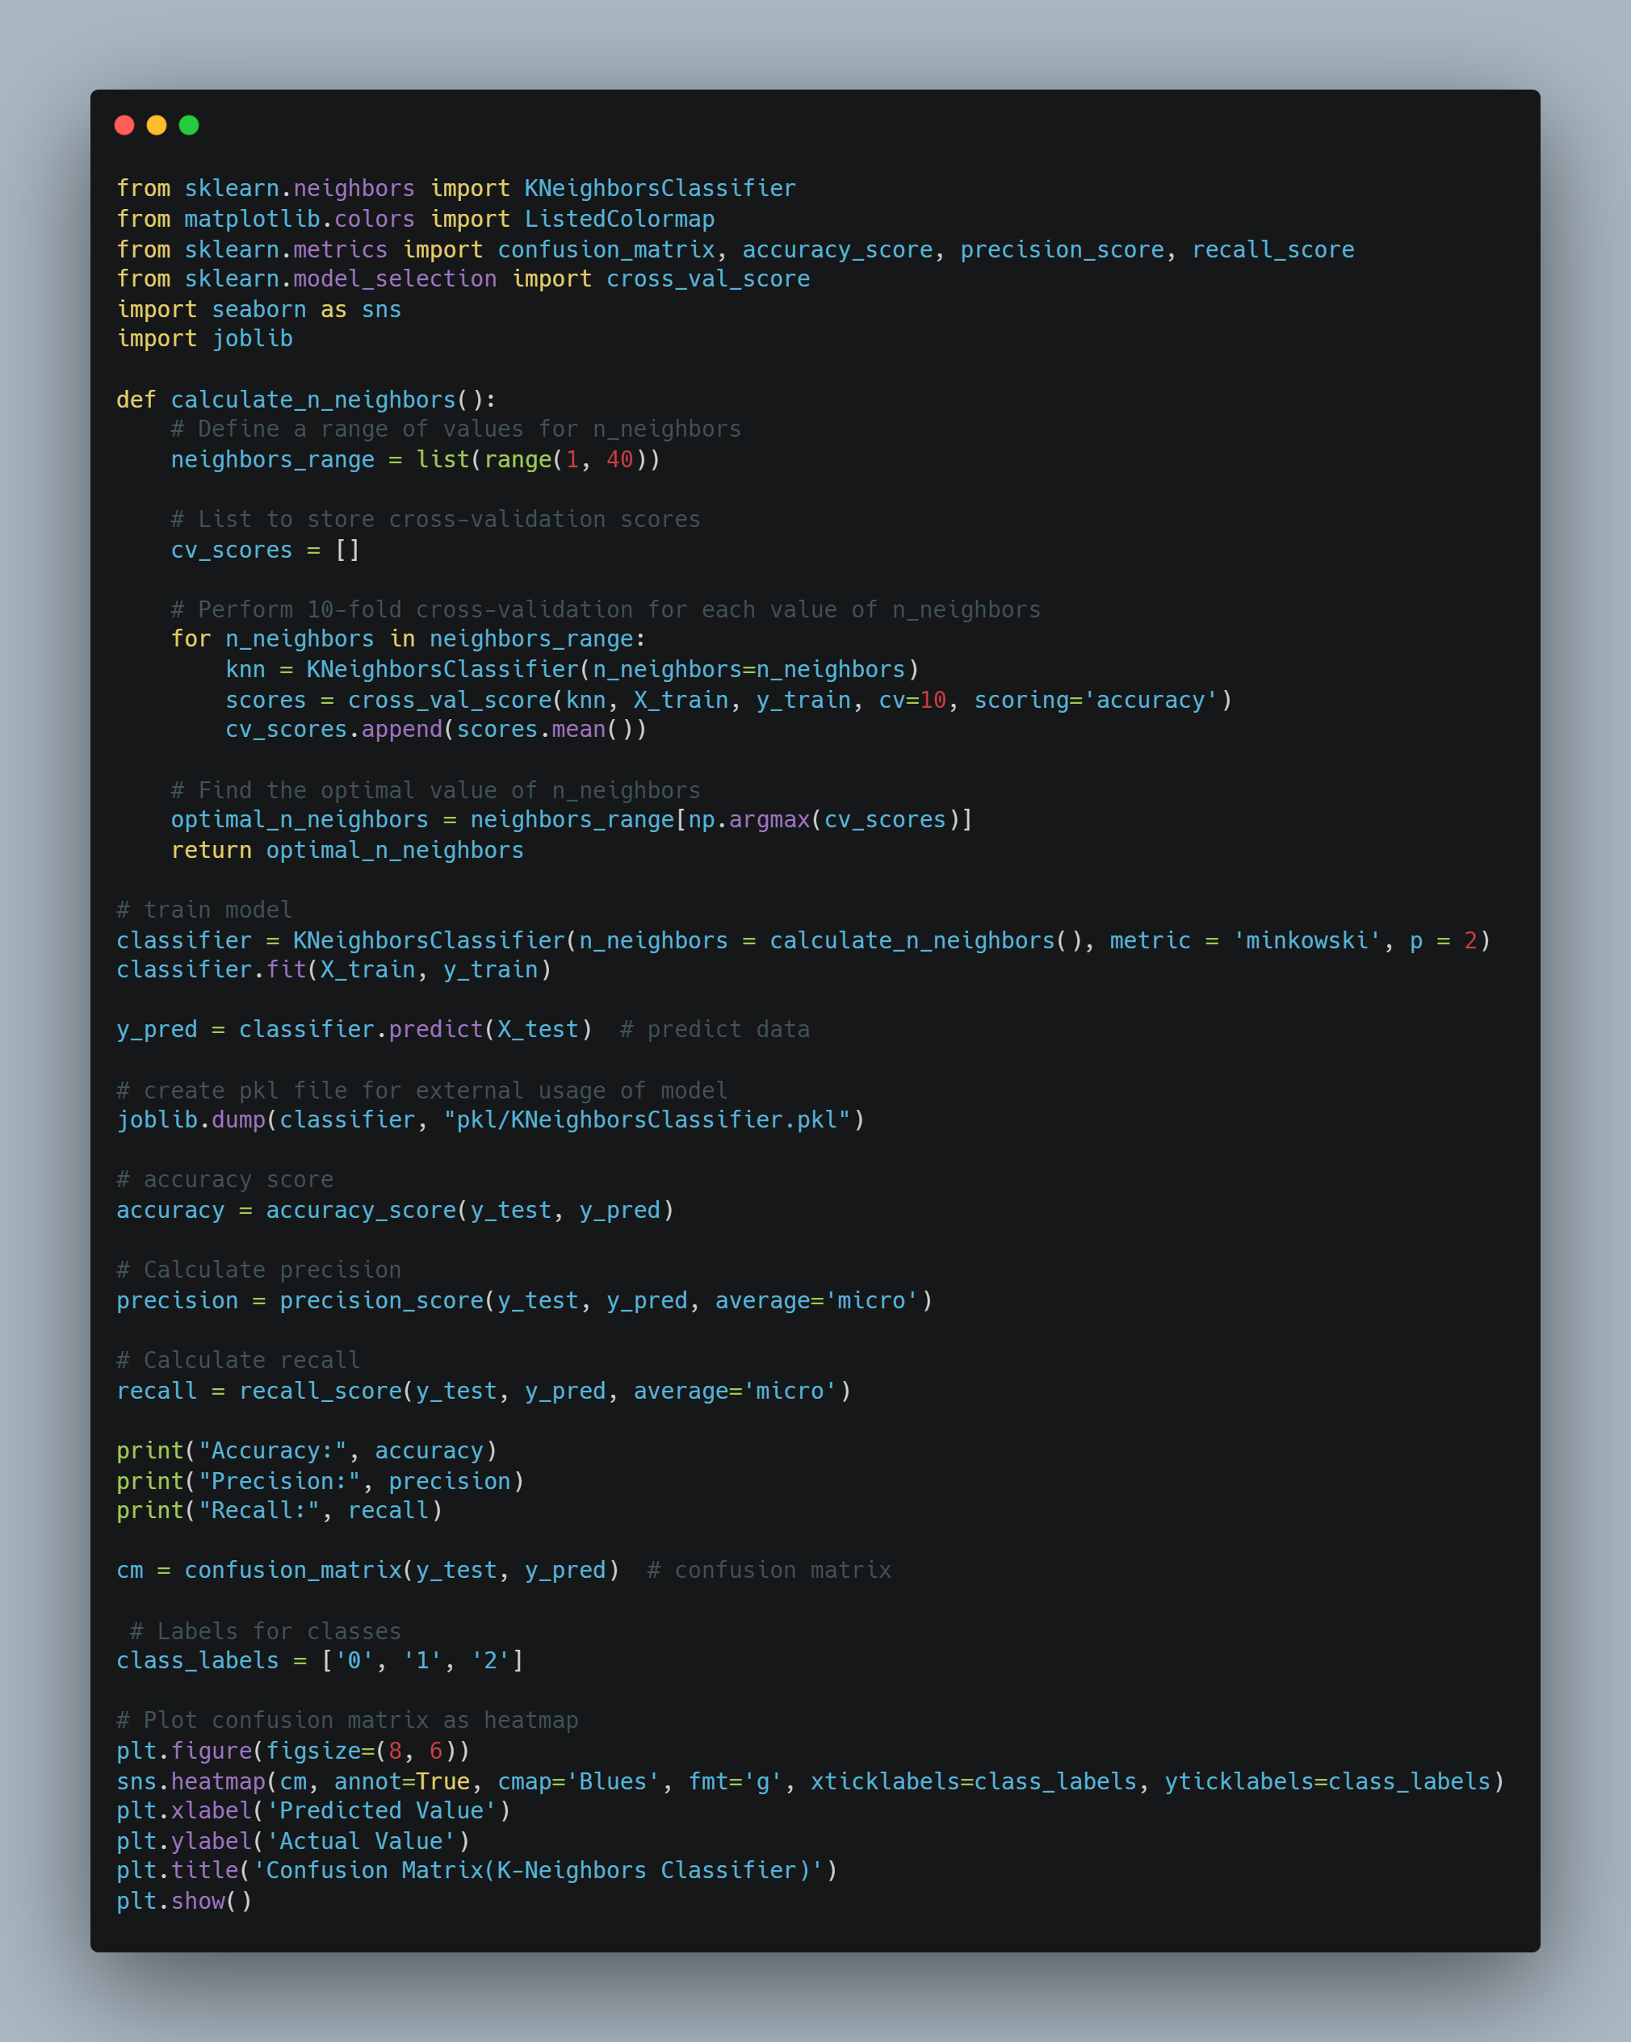

**Step 4:** Create and Setup Flask webapp

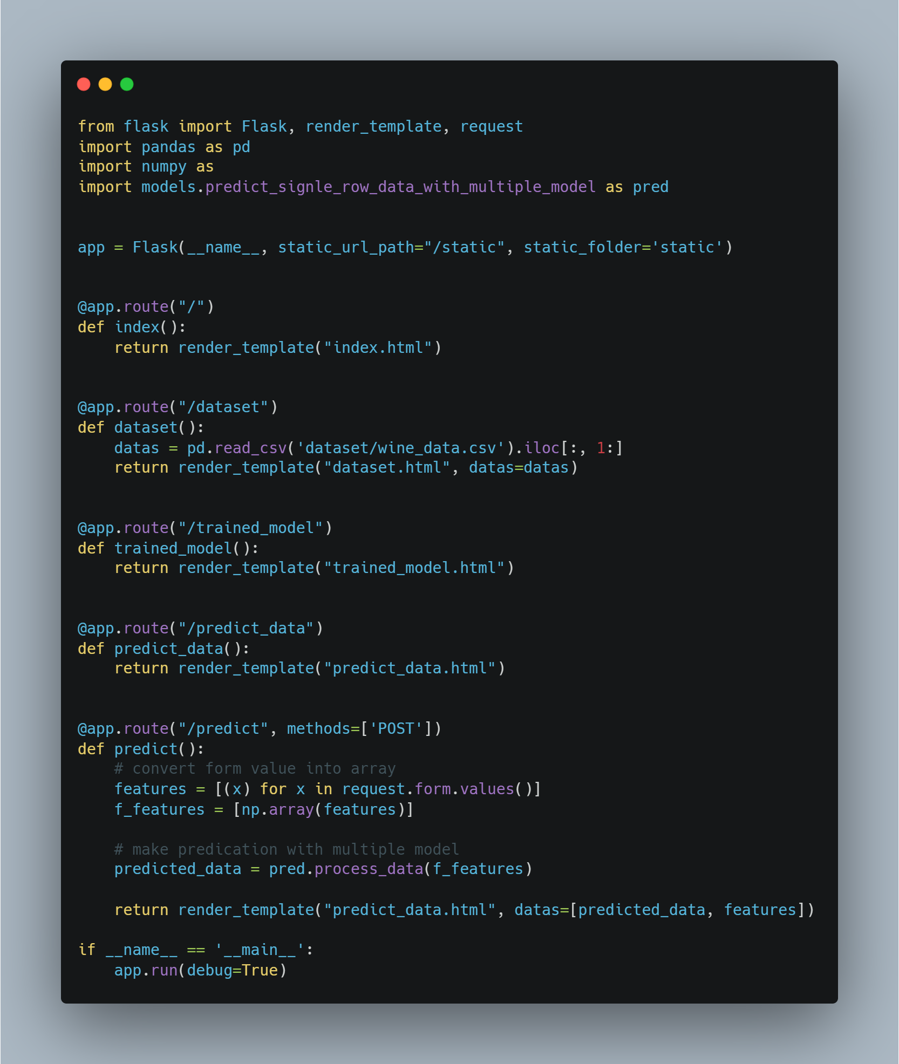

**Step 5:** Create Web Form for Input Data

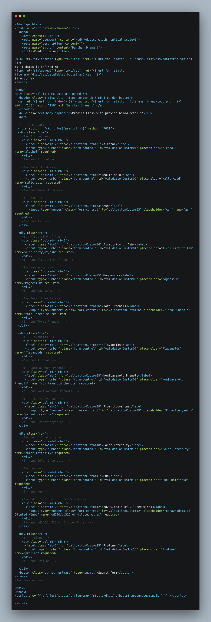



**Step 6:** Visualize predictions

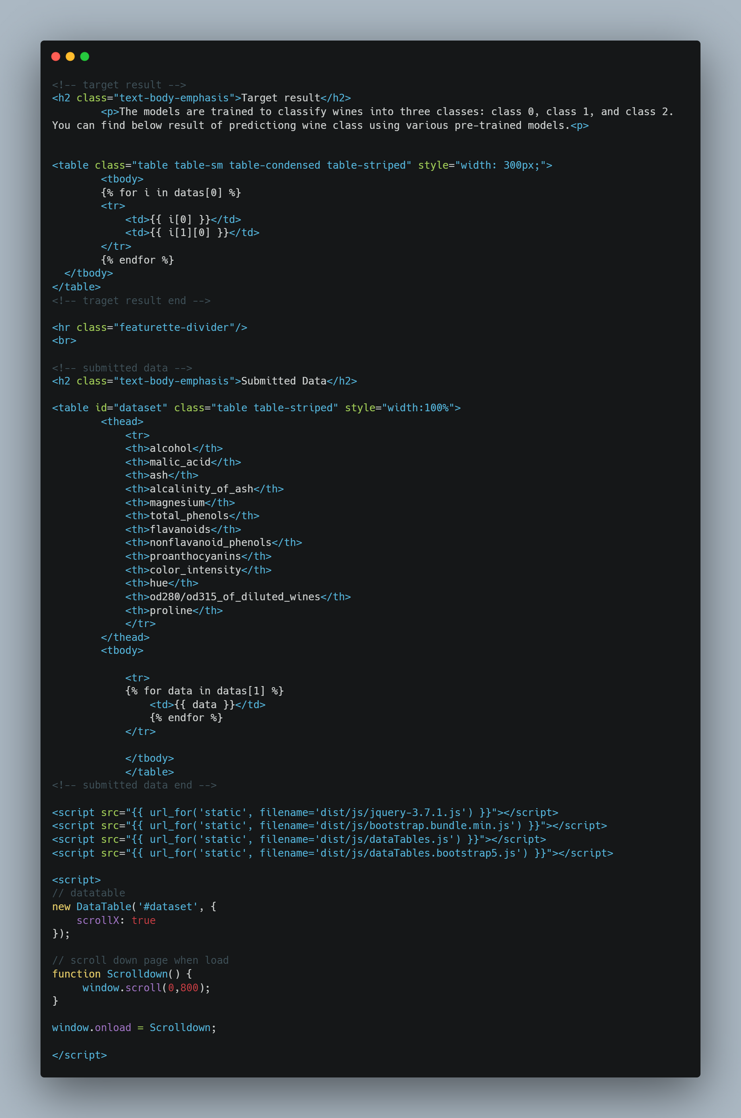

**Snapshot of web page**

**Index Page**

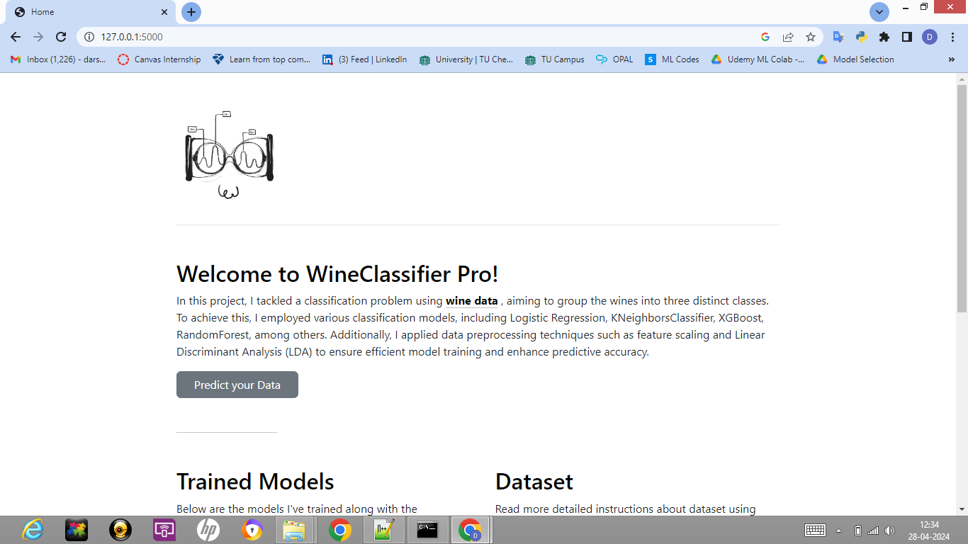

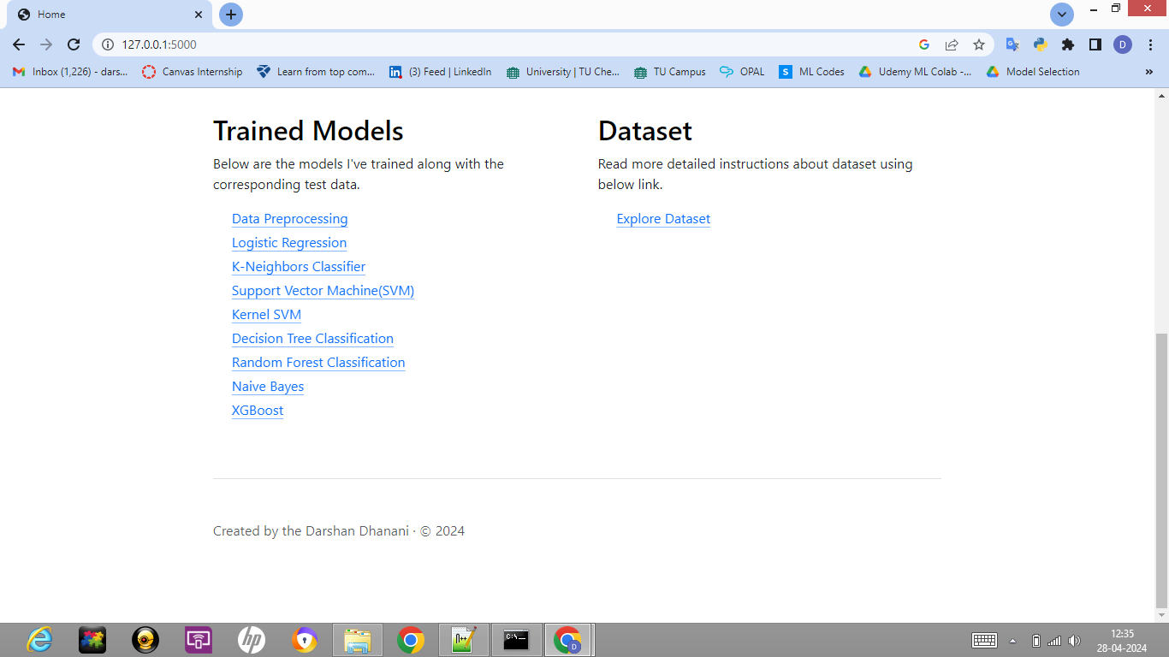

**Input Form**

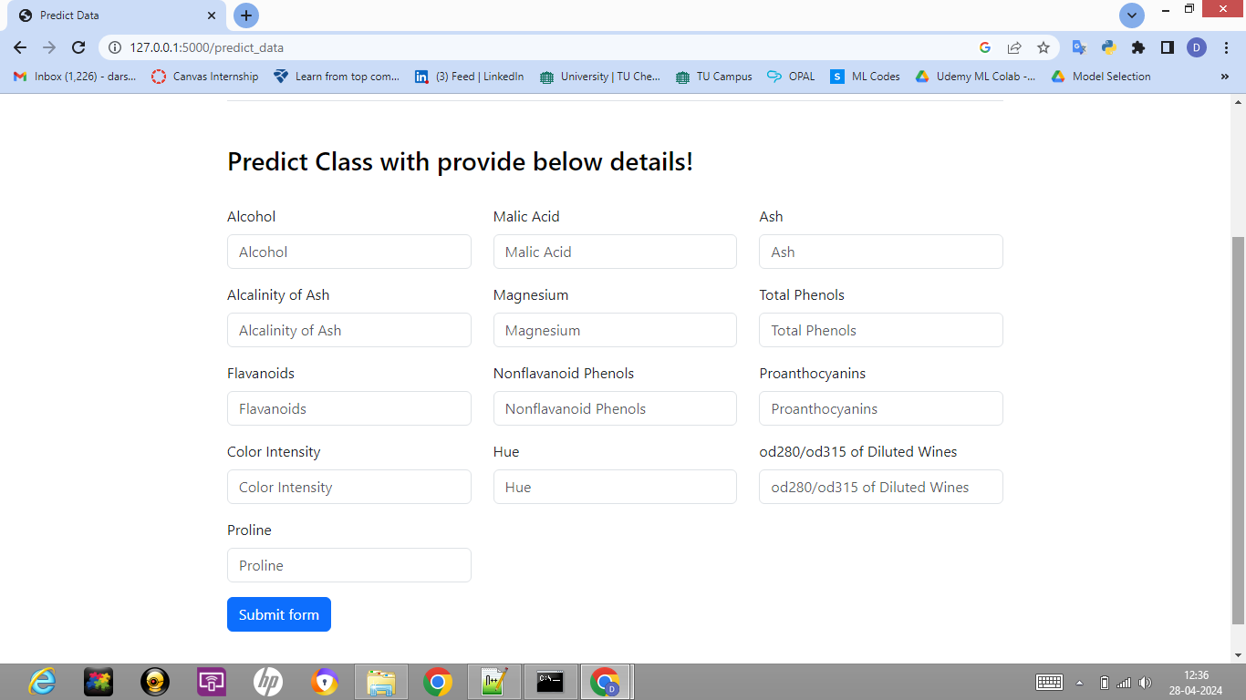

**Result Prediction**

